Welcome!
Date
Name
Spouse
Address
City
State Zip _________
Email

Please Contact By
❑ Card  Phone  Visit

Telephone Best Time to Call
Home ______________
Work ______________

Guest: First Time Second Time
Are you a church member: yes no
Church
City, State

Circle Appropriate Age/Grade Group(s)
Preschool: Ages: B-1 2-3 4-5
Children: Grades: K 1 2 3 4 5 6
Youth: Grades: 7 8 9 10 11 12
Adults: Ages:18-29 30s 40s 50s 60s+

How did you learn about our church?
Newspaper Friend Yellow Pages Mail
Other

I am a guest of:

New in the Community? Yes No
Names & ages of children at home

Weekly Service & Activity Schedule

June 11, 2017
9:30 a.m. New Commandment Kids
9:45 a.m. Sunday School
10:45 a.m. Worship Service
Lunch on the Grounds
No Evening Service

Week of June 11, 2017

Wednesday 6:30 pm………………..…Meal/Bible Study
Friday 6:30 pm……………..……………..Men’s 42 Night

June
18………………………………………..……….Father’s Day
22……………………………………………Adult Fellowship
22…………………………………………..Stamp Card Class
25………………………………..…………Business Meeting

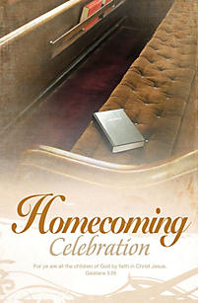
Knobbs Springs is celebrating 157 years of blessings!!

Join us after the service for a pot luck lunch on the grounds. If you didn’t bring anything, please stay anyway. There is always plenty!!

Make & Take Card Class with a 4th of July Theme

Thursday, June 22 6pm – 9pm in the Fellowship Hall

The cost is $20 and attendees will take home 4 cards. Contact Brenda Williams if you are interested.
512-925-8572



Knobbs Springs Baptist Church

June 11, 2017

Church Information:

KnobbsSpringsBC.com KnobbsSpringsBaptist@gmail.com

1662 CR 305, McDade, Texas 78650 512-273-2743

David Atwood, Pastor Cell 512-470-5098

Patti Radford, Office Manager Cell 512-968-7821

